Text Structure 5
Directions: Read the passages and on a sheet of paper, put the information from each passage into an appropriate graphic organizer. The following graphic organizers are examples. Feel free to make changes if necessary.
Chronological | Sequence | Cause and Effect | Problem and Solution | Compare and Contrast
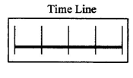 | 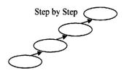 | 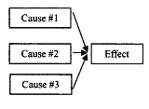 | 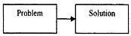 | 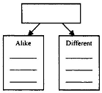

1. Tornados and Hurricanes
Hurricanes and tornados are both amazing yet deadly natural phenomena. Both generate deadly conditions, but in different ways. Tornados are likely to damage people and property with their high winds, which go up to 300 miles per hour, but hurricanes are generally more feared for their flooding. Also, hurricanes can produce tornados, which makes them quite dangerous indeed.

Compare and Contrast

2. Where Did This Tornado Come From?
No one knows exactly what causes tornados, but some scientists believe that when warm air meets cold air, a tornado may form. The reason for this is that the warm air is lighter than the cold air, so it rises up fast and meets different winds moving different directions. Under the right conditions, this can cause a tornado. Though there is still much mystery surrounding tornados, many people believe that when warm moist air meets cool dry air, tornados can result.

Cause and Effect

3. Twista
Carl Terrell Mitchell, better known by his stage name Twista, was born in 1972. Nineteen years later Mitchell's first album, "Runnin' Off at da Mouth," debuted. In 1997, after appearing on a hit song, Twistawas signed to Atlantic Records. Under that label he released "Adrenaline Rush" and formed the group Speedknot Mobstaz in 1998. His 2004 album Kamikaze went to number-one on the U.S. Billboard 200 album chart.

Chronological

4. The Twist
The twist is a dance inspired by rock and roll music. To do the Twist, first stand with your feet approximately shoulder width apart. The torso may be squared to the knees and hips, or turned at an angle so one foot is farther forward than the other. Then, hold your arms out from your body, bent at your elbow. Next, rotate your hips, torso, and legs as a single unit with your arms staying more or less stationary. Every so often lift one leg off of the floor for styling. Now you're doing the twist!

Sequence

5. Dancing
There are many reasons why people dance. Some people dance for fun, just because they enjoy dancing. At other times, people dance for exercise or for weight loss, because dancing can really get your heart beating. Also, sometimes people dance to try to get boyfriends or girlfriends. Some people think that good dancing is attractive. There are many reasons why people dance.

Cause and Effect

